**Non-Linearity of Avalanche Photodiodes (APD) due to Multiplication factor and Complete output model of APD – A Report**

**Introduction:**

In this report I will detail my study regarding the non-linearity of avalanche photodiodes (APD) subjected to varying illumination. I also simulated the results using MATLAB to obtain the complete output model of the photodiode. In this setting we reverse bias the APD under a constant voltage and vary the input power given to it over a long range (I.e., from $${10}^{−6}$$ to $${10}^{1}$$ Watts).

**Circuit Diagram:**

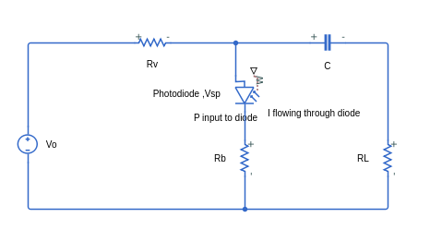

Fig 1: A simplified equivalent circuit of APD

**Derivation:**

I will go through the core part of the derivation; the detailed derivation is covered in [1] and [2]

In the derivation, the notations used are as follows

$$Vo$$ (Bias Voltage)

$$Vsp$$ (Voltage across the diode)

$$V_{B}$$ (Breakdown Voltage)

$$Mst$$ (Multiplication Gain/Factor)

$$Iph$$ (Primary Photo-Current)

$$P$$ (Input-Power in watts)

$$Rv$$ (Series Resistance)

$$Ir$$ (Dark/Reverse Saturation Current)

$$r$$ (A constant that depends on the material of APD)

$$I$$ (Multiplied Photo-Current)

$$R_{L}$$ (Load Resistance)

$$V_{L}$$ (Voltage across Load)

$$L_{p}$$ (Normalized Input Power)

Now, for an APD, wkt:

$$I = M\left[Iph+Ir\right] → 1$$

Also, the multiplication factor for an APD is given by the formula

$$Mst = \frac{1}{1−{\left(\frac{Vsp}{V_{B}}\right)}^{r}} → 2$$

Now, from the circuit diagram, by applying Kirchoff’s loop laws and upon simplification we yield the next equation:

$${\left(1−\frac{1}{Mst}\right)}^{\frac{1}{r}}−V_{OB}+L_{P}Mst = 0 → 3$$

Here, $$V_{OB } = \frac{Vo}{V_{B}}$$ and **the important thing is that we assume $$Mst$$ >>** 1,hence finally we get equation 4,

$$Mst = \frac{1−V_{OB}}{2L_{P}}\left[\frac{\sqrt{\left(1+4L_{P}\right)}}{r\left(1−V_{OB}\right)}−1\right] → 4$$

**Simulation Results:**

From equation 4, I plotted two characteristics in MATLAB which is $$P v Mst$$ and $$P v I$$. I set some parameters for the simulation as follows:

$$Rs$$ = 50 ohms, $$V_{B}$$ = 200 V, $$r$$ =1.5, Initial value of Multiplication factor = 100 (we assumed $$Mst$$ >> 1 in our derivation by which we mean the starting or initial value).

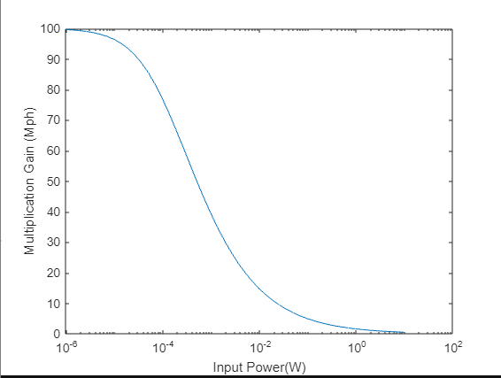

Fig 2: Multiplication Gain v Input Power Simulated Plot

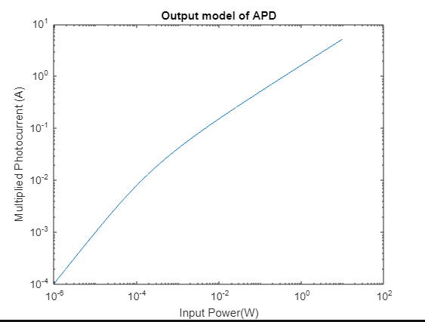

Fig 3: Multiplied Photocurrent v Input Power Simulated Plot

**Observation:**

Now we can make an analytical observation from the plots side by side with making a theoretical observation from equation 4.

If we observe equation 4, for very low power levels $$Mst$$ can be approximated as $$1/r\left(1−V_{OB}\right)$$, which means the multiplication factor is nearly a constant for very low light power levels.

From the plots, for very low light power levels (from 10^-6 to 10^-5) the $$P v Mst$$ plot is nearly a constant, and the $$P v I$$ plot has a linear trend, thus confirming the theoretical estimation that multiplication factor is nearly a constant for lower light power levels and the output multiplied photocurrent has a linear response to input power.

Now, for very high light power levels, $$Mst$$ is proportional to $$\frac{1}{\left(L_{P}⋅\sqrt{L_{P}}\right)}$$, which means the multiplication factor non-linearly reduces when $$L_{P}$$ or $$P$$ is increased.

We can clearly see the non-linear trend for both plots for $$P$$ values greater than 10^-5, which confirms the theoretical observation.

And from this we obtained the complete model of the APD from the graph $$P$$ v $$I$$, which contains both trends linearity as well as non-linearity.

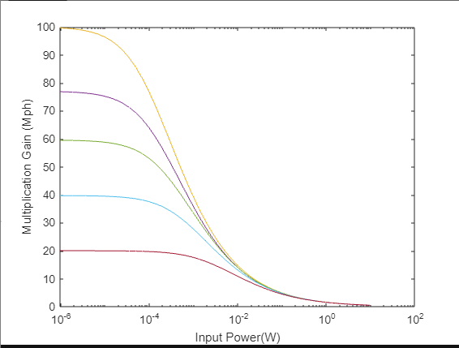

Fig 4: A Simulated Plot tracking how Multiplication gain varies with Input Power for different initial Mst

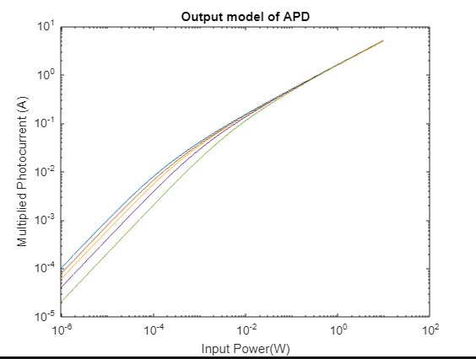

Fig 5 : A Simulated Plot tracking how Multiplied Photo-Current varies with Input Power for different initial Mst

Now other important thing is note is that the ratio of bias voltage to breakdown voltage determines for what ‘length of power range’ does the multiplication factor remain nearly constant before starting to drop down, If the bias voltage is equal to breakdown voltage of the diode, then the multiplication factor starts to decrease as soon as we flash light into the APD, but for lower and lower ratios (lower initial values of multiplication factors for a constant diode material), the multiplication factor remains constant for greater range of input power values and thus the APD remains linear for the said range of input which is a desirable property of APD. The above is a plot depicting this phenomenon. In the simulated plots above, I have simulated how the multiplication gain and multiplied photo-current varies with input power for different initial multiplication gain values (100, 80, 60, 40 and 20 respectively). Thus, we can choose a particular APD with a particular initial multiplication gain according to our needs.

**References:**

[1] C. C. Timmermann, "The static and dynamic multiplication factor in avalanche photodiode optical receivers," in IEEE Transactions on Electron Devices, vol. 24, no. 12, pp. 1317-1322, Dec. 1977, doi: 10.1109/T-ED.1977.19006.

[2] W. Liu and Z. Xu, "APD Nonlinearity and Its Impact on PAM-Based Visible Light Communication," in IEEE Communications Letters, vol. 24, no. 5, pp. 1057-1061, May 2020, doi: 10.1109/LCOMM.2020.2973995.